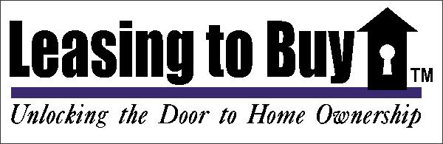

**Dear Homeowner,**

**Are you FRUSTRATED with the time it is taking to find a buyer for your home? Are you asking less for your house than you would like? Do you have low equity?**

There are numerous advantages to using *Leasing to Buy*, such as:

* We can offer your asking price in most cases!
* We can normally have a tenant/buyer within 45-60 days!
* We can work with your current Realtor® or you can market the property at the same time!
* **Our tenant/buyers can usually close within 8-10 months!**
* **We do not charge you a fee at all. EVER!**
* We are a BBB Accredited Business!

Established in 2003, Leasing to Buy is the **LARGEST** company of it’s kind in Texas, and the **ONLY** one that is a member of the Better Business Bureau with an A+ rating!

We have lease purchased over 900 houses from owners offering the owner top dollar! We currently have over 1000 people in our database looking to get into our lease purchase program.

**Call us at 817-980-0068!**

**WHAT IS YOUR CURRENT SITUATION?**

* **Are you trying to relocate but afraid of having 2 house payments?**
* **Is your house VACANT and you are making payments on an empty house?**
* **Are you closing on your new house but yours hasn’t sold yet?**

**There IS a solution!**

**Tap into the MASSIVE pool of potential buyers that want to pay you TOP DOLLAR for your house, take care of all maintenance and obtain financing in 8-10 months!**

**Call or e-mail today for a FREE lease purchase analysis.**

**Call 817-980-0068**

**Or e-mail us! John@leasingtobuy.com**

**Take time for a 60 second phone call, and we can immediately start putting together a plan so you’ll know how to get all of your equity you’ve worked so hard for.**

Think About This..

How big do you think the pool of buyers is that can qualify and close within a few weeks? It’s smaller than you think! Now, of those who can get financing, how many houses do you think they have to choose from? 1500? 2000? How do you compete with that? The answer is simple. Tap into the pool of buyers that are *very close* to financing. How big do you think that pool of people is? MASSIVE!

Now What Do I Do..

If any of this sounds interesting to you, and you would like more information about how the lease purchase works, and if it might be the solution you need, simply call or e-mail and we can quickly answer your questions and explain everything. The process is actually very safe and simple!

Call or Email Today!

817-980-0068

[John@leasingtobuy.com](mailto:John@leasingtobuy.com)

Have You Thought About….

LEASE PURCHASE?

A Lease Purchase is simply a short term lease agreement combined with an option that allows the tenant/buyer time that they need to finish getting ready for financing and therefore will pay top dollar!

Consider the Benefits…

* **No Haggling!** Get FULL Price!
* **Fill the House Quickly!**
* **Maintenance is Covered!** Most maintenance is covered by the Home Warranty the buyers get
* **You are NOT a Landlord!** These aren’t renters! They are in the process of getting permanent financing.
* **You Don’t Pay Us a Commission!**
* **End the frustration!**

**CALL US NOW TO LEARN HOW A LEASE PURCHASE CAN HELP!**

**Office: 817-980-0068 JOHN@Leasingtobuy.com**

**950 E. State Highway 114 Suite 160 Southlake, TX 760092**

